

**UCS1712-Graphics and Multimedia Lab**

**Programming Assignment 6**

**2D Composite Transformations and Windowing in C++ using OpenGL**

Name: Jayannthan P T

Dept: CSE ‘A’

Roll No.: 205001049

a) To compute the composite transformation matrix for any 2 transformations input by the user and apply it on the object.

1. Translation
2. Rotation
3. Scaling
4. Reflection
5. Shearing

Display the original and the transformed object.

Note: Use Homogeneous coordinate representations and matrix multiplication to perform transformations. Divide the output window into four quadrants. (Use LINES primitive to draw x and y axis)

b) Create a window with any 2D object and a different sized viewport. Apply window to viewport transformation on the object. Display both window and viewport.

**Source code:**

#define **GL_SILENCE_DEPRECATION**

#include<GLUT/glut.h>

#include<stdio.h>

#include<iostream>

#include<math.h>

using namespace std;

float **toRad**(float xDeg) {

    return xDeg * 3.14159 / 180;

}

void **myInit**() {

**glClearColor**(1, 1, 1, 1); // violet

**glColor3f**(0.0f, 0.0f, 0.5f); //dark blue

    //glPointSize(10);

**glMatrixMode**(GL_PROJECTION);

**glLineWidth**(2);

**glLoadIdentity**();

**gluOrtho2D**(0.0, 640.0, 0.0, 480.0);

}

void **displayPoint**(float x, float y) {

**glBegin**(GL_POINTS);

**glVertex2d**(x + 320, y + 240);

**glEnd**();

}

void **displayHomogeneousPoint**(float* h) {

    float x = *(h + 0);

    float y = *(h + 1);

**glColor4f**(0, 1, 0.4, 1); //green

**displayPoint**(x, y);

}

void **displayLine**(int x1, int y1, int x2, int y2) {

**glBegin**(GL_LINES);

**glVertex2d**(x1 + 320, y1 + 240);

**glVertex2d**(x2 + 320, y2 + 240);

**glEnd**();

}

void **displayTriangle**(int x1, int y1, int x2, int y2, int x3, int y3) {

**glBegin**(GL_TRIANGLES);

**glVertex2d**(x1 + 320, y1 + 240);

**glVertex2d**(x2 + 320, y2 + 240);

**glVertex2d**(x3 + 320, y3 + 240);

**glEnd**();

}

void **displayTransformedTriangle**(float* p1, float* p2, float* p3) {

    float x1 = *(p1 + 0);

    float y1 = *(p1 + 1);

    float x2 = *(p2 + 0);

    float y2 = *(p2 + 1);

    float x3 = *(p3 + 0);

    float y3 = *(p3 + 1);

**glColor4f**(0, 1, 0.4, 1); //green

**displayTriangle**(x1, y1, x2, y2, x3, y3);

}

void **drawPlane**() {

**glClear**(GL_COLOR_BUFFER_BIT);

**glColor4f**(0, 0, 0, 1); //yellow

**displayLine**(-320, 0, 320, 0); //x-axis

**displayLine**(0, -240, 0, 240); //y-axis

**glFlush**();

}

void **printMenu**() {

    cout **<<** "1 - Translation" **<<** **endl**;

    cout **<<** "2 - Rotation about origin" **<<** **endl**;

    cout **<<** "3 - Rotation wrt fixed point" **<<** **endl**;

    cout **<<** "4 - Scaling wrt origin" **<<** **endl**;

    cout **<<** "5 - Scaling wrt fixed point" **<<** **endl**;

    cout **<<** "6 - Reflection wrt x-axis" **<<** **endl**;

    cout **<<** "7 - Reflection wrt y-axis" **<<** **endl**;

    cout **<<** "8 - Reflection wrt origin" **<<** **endl**;

    cout **<<** "9 - Reflection wrt line x=y" **<<** **endl**;

    cout **<<** "10 - Shearing along x-dir" **<<** **endl**;

    cout **<<** "11 - Shearing along y-dir" **<<** **endl**;

    cout **<<** "0 - All done" **<<** **endl**;

}

void **printMatrix**(float* arr, int m, int n)

{

    int i, j;

    for (i = 0; i < m; i++) {

        for (j = 0; j < n; j++)

            cout **<<** *((arr + i * n) + j) **<<** " ";

        cout **<<** **endl**;

    }

}

float* **mulMatrix**(float* a, int m1, int n1, float* b, int m2, int n2) {

    if (n1 != m2) {

        cout **<<** "Multiplication Input Error" **<<** **endl**;

        return **NULL**;

    }

    float* res = new float[m1 * n2];

    for (int i = 0; i < m1; i++) {

        for (int j = 0; j < n2; j++) {

            *((res + i * n2) + j) = 0;

            for (int k = 0; k < n1; k++) {

                *((res + i * n2) + j) += *((a + i * n1) + k) * *((b + k * n2) + j);

            }

        }

    }

    return res;

}

void **printPoint**(float* P) {

**printMatrix**(P, 3, 1);

}

void **printMatrix3**(float* M) {

**printMatrix**(M, 3, 3);

}

float* **transformPoint**(float* m, float* p) {

    return **mulMatrix**(m, 3, 3, p, 3, 1);

}

float* **mulTransforms**(float* m1, float* m2) {

    return **mulMatrix**(m1, 3, 3, m2, 3, 3);

}

float* **getTransformationMatrix**() {

    cout **<<** "COMPOSITE TRANSFORMATION" **<<** **endl**;

    float* compositeMatrix = new float[3 * 3];

    for (int i = 0; i < 3; i++) {

        for (int j = 0; j < 3; j++) {

            compositeMatrix[i * 3 + j] = (i == j) ? 1 : 0;

        }

    }

**printMenu**();

    int ch;

    do {

        cout **<<** "\nChoose required transformation: ";

        cin **>>** ch;

        switch (ch) {

        case 1: {

            cout **<<** "TRANSLATION" **<<** **endl**;

            float tx, ty;

            cout **<<** "Enter translation values: ";

            cin **>>** tx **>>** ty;

            float T[3][3] = {

                {1, 0, tx},

                {0, 1, ty},

                {0, 0, 1}

            };

            float* temp = **mulTransforms**((float*)T, compositeMatrix);

            delete[] compositeMatrix;

            compositeMatrix = temp;

            break;

        }

        case 2: {

            cout **<<** "ROTATION ABOUT ORIGIN" **<<** **endl**;

            float angle;

            cout **<<** "Enter rotation angle: ";

            cin **>>** angle;

            float theta = **toRad**(angle);

            float c = **cos**(theta);

            float s = **sin**(theta);

            float R[3][3] = {

                {c, -s, 0},

                {s, c, 0},

                {0, 0, 1}

            };

            float* temp = **mulTransforms**((float*)R, compositeMatrix);

            delete[] compositeMatrix;

            compositeMatrix = temp;

            break;

        }

        case 3: {

            cout **<<** "ROTATION WRT FIXED POINT" **<<** **endl**;

            float angle;

            cout **<<** "Enter rotation angle: ";

            cin **>>** angle;

            float theta = **toRad**(angle);

            float c = **cos**(theta);

            float s = **sin**(theta);

            float xr, yr;

            cout **<<** "Enter fixed point coords: ";

            cin **>>** xr **>>** yr;

            float R[3][3] = {

                {c, -s, (xr * (1 - c)) + (yr * s)},

                {s, c, (yr * (1 - c)) - (xr * s)},

                {0, 0, 1}

            };

            float* temp = **mulTransforms**((float*)R, compositeMatrix);

            delete[] compositeMatrix;

            compositeMatrix = temp;

            break;

        }

        case 4: {

            cout **<<** "SCALING WRT ORIGIN" **<<** **endl**;

            float sx, sy;

            cout **<<** "Enter scaling factor values: ";

            cin **>>** sx **>>** sy;

            float S[3][3] = {

                {sx, 0, 0},

                {0, sy, 0},

                {0, 0, 1}

            };

            float* temp = **mulTransforms**((float*)S, compositeMatrix);

            delete[] compositeMatrix;

            compositeMatrix = temp;

            break;

        }

        case 5: {

            cout **<<** "SCALING WRT FIXED POINT" **<<** **endl**;

            float sx, sy;

            cout **<<** "Enter scaling factor values: ";

            cin **>>** sx **>>** sy;

            float xf, yf;

            cout **<<** "Enter fixed point coords: ";

            cin **>>** xf **>>** yf;

            float S[3][3] = {

                {sx, 0, xf * (1 - sx)},

                {0, sy, yf * (1 - sy)},

                {0, 0, 1}

            };

            float* temp = **mulTransforms**((float*)S, compositeMatrix);

            delete[] compositeMatrix;

            compositeMatrix = temp;

            break;

        }

        case 6: {

            cout **<<** "REFLECTION WRT X-AXIS" **<<** **endl**;

            float RF[3][3] = {

                {1, 0, 0},

                {0, -1, 0},

                {0, 0, 1}

            };

            float* temp = **mulTransforms**((float*)RF, compositeMatrix);

            delete[] compositeMatrix;

            compositeMatrix = temp;

            break;

        }

        case 7: {

            cout **<<** "REFLECTION WRT Y-AXIS" **<<** **endl**;

            float RF[3][3] = {

                {-1, 0, 0},

                {0, 1, 0},

                {0, 0, 1}

            };

            float* temp = **mulTransforms**((float*)RF, compositeMatrix);

            delete[] compositeMatrix;

            compositeMatrix = temp;

            break;

        }

        case 8: {

            cout **<<** "REFLECTION WRT ORIGIN" **<<** **endl**;

            float RF[3][3] = {

                {-1, 0, 0},

                {0, -1, 0},

                {0, 0, 1}

            };

            float* temp = **mulTransforms**((float*)RF, compositeMatrix);

            delete[] compositeMatrix;

            compositeMatrix = temp;

            break;

        }

        case 9: {

            cout **<<** "REFLECTION WRT LINE X=Y" **<<** **endl**;

            float RF[3][3] = {

                {0, 1, 0},

                {1, 0, 0},

                {0, 0, 1}

            };

            float* temp = **mulTransforms**((float*)RF, compositeMatrix);

            delete[] compositeMatrix;

            compositeMatrix = temp;

            break;

        }

        case 10: {

            cout **<<** "SHEARING ALONG X-DIR" **<<** **endl**;

            float shx, yref = 0;

            cout **<<** "Enter shear value: ";

            cin **>>** shx;

            cout **<<** "Enter yref value: ";

            cin **>>** yref;

            float SH[3][3] = {

                {1, shx,-shx * yref},

                {0, 1, 0},

                {0, 0, 1}

            };

            float* temp = **mulTransforms**((float*)SH, compositeMatrix);

            delete[] compositeMatrix;

            compositeMatrix = temp;

            break;

        }

        case 11: {

            cout **<<** "SHEARING ALONG Y-DIR" **<<** **endl**;

            float shy, xref = 0;

            cout **<<** "Enter shear value: ";

            cin **>>** shy;

            cout **<<** "Enter yref value: ";

            cin **>>** xref;

            float SH[3][3] = {

                {1, 0, 0},

                {shy, 1, -shy * xref},

                {0, 0, 1}

            };

            float* temp = **mulTransforms**((float*)SH, compositeMatrix);

            delete[] compositeMatrix;

            compositeMatrix = temp;

            break;

        }

        case 0: {

            cout **<<** "ALL DONE" **<<** **endl**;

        }

        default: break;

        }

    } while (ch != 0);

    return compositeMatrix;

}

void **plotTransform**()

{

    cout **<<** "TRANSFORMATION OF A TRIANGLE" **<<** **endl**;

    //Point P1

    float x1, y1;

    cout **<<** "Enter point P1 coords: ";

    cin **>>** x1 **>>** y1;

    float* P1 = new float[3] { {x1}, { y1 }, { 1 } };

    cout **<<** "Homogeneous representation of P1: " **<<** **endl**;

**printPoint**(P1);

    cout **<<** **endl**;

    //Point P2

    float x2, y2;

    cout **<<** "Enter point P2 coords: ";

    cin **>>** x2 **>>** y2;

    float* P2 = new float[3] { {x2}, { y2 }, { 1 } };

    cout **<<** "Homogeneous representation of P2: " **<<** **endl**;

**printPoint**(P2);

    cout **<<** **endl**;

    //Point P3

    float x3, y3;

    cout **<<** "Enter point P3 coords: ";

    cin **>>** x3 **>>** y3;

    float* P3 = new float[3] { {x3}, { y3 }, { 1 } };

    cout **<<** "Homogeneous representation of P3: " **<<** **endl**;

**printPoint**(P3);

    cout **<<** **endl**;

    //plot triangle

**displayTriangle**(x1, y1, x2, y2, x3, y3);

    float* M = **getTransformationMatrix**();

    if (M != **NULL**) {

        cout **<<** "\nTransformation Matrix: " **<<** **endl**;

**printMatrix3**(M);

        cout **<<** "\nP1': " **<<** **endl**;

        float* Q1 = **transformPoint**(M, P1);

**printPoint**(Q1);

        cout **<<** "\nP2': " **<<** **endl**;

        float* Q2 = **transformPoint**(M, P2);

**printPoint**(Q2);

        cout **<<** "\nP3': " **<<** **endl**;

        float* Q3 = **transformPoint**(M, P3);

**printPoint**(Q3);

**displayTransformedTriangle**(Q1, Q2, Q3);

        delete[] Q1;

        delete[] Q2;

        delete[] Q3;

    }

    delete[] M;

    delete[] P1;

    delete[] P2;

    delete[] P3;

}

void **plotChart**() {

**glClear**(GL_COLOR_BUFFER_BIT);

**drawPlane**();

**plotTransform**();

**glFlush**();

}

int **main**(int argc, char* argv[]) {

**glutInit**(&argc, argv);

**glutInitDisplayMode**(GLUT_SINGLE | GLUT_RGBA);

**glutInitWindowSize**(640, 480);

**glutCreateWindow**("Transformations");

**glutDisplayFunc**(**plotChart**);

**myInit**();

**glutMainLoop**();

    return 1;

}

**Output**

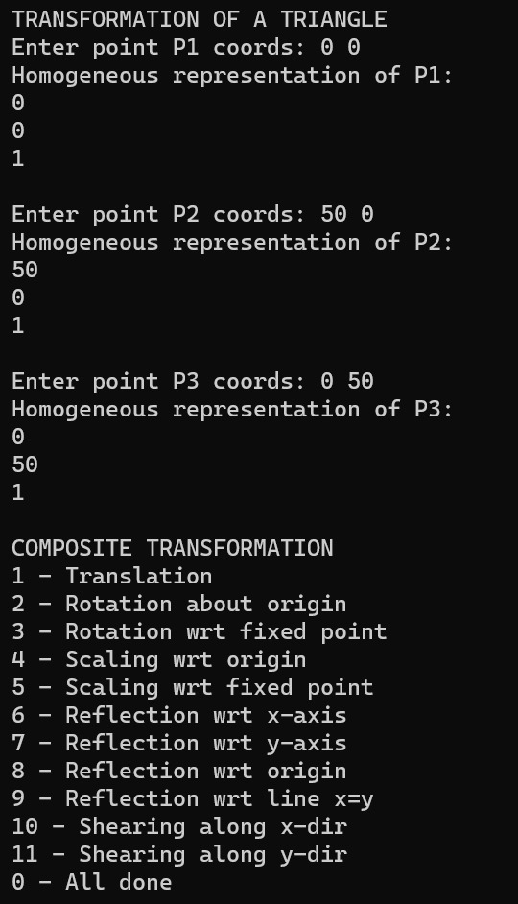 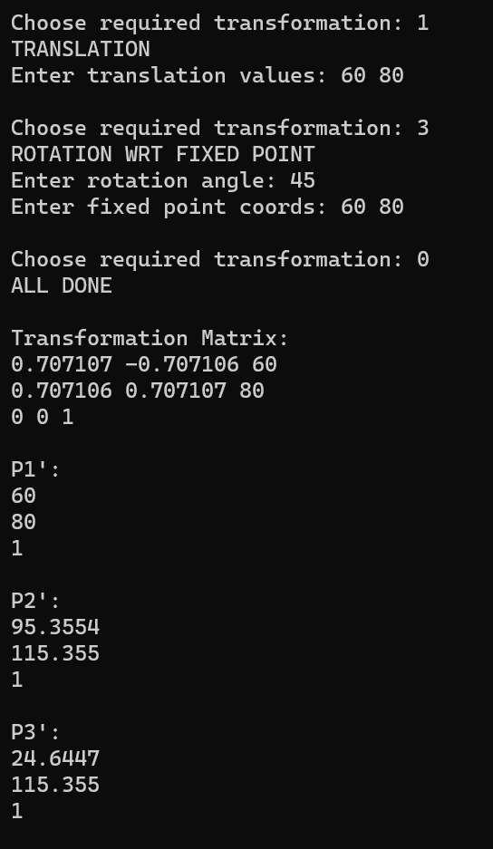

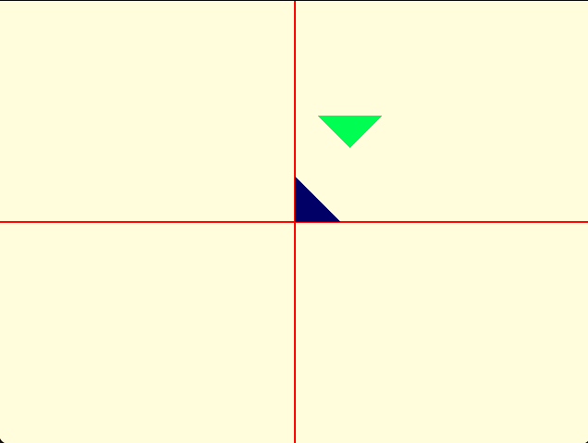

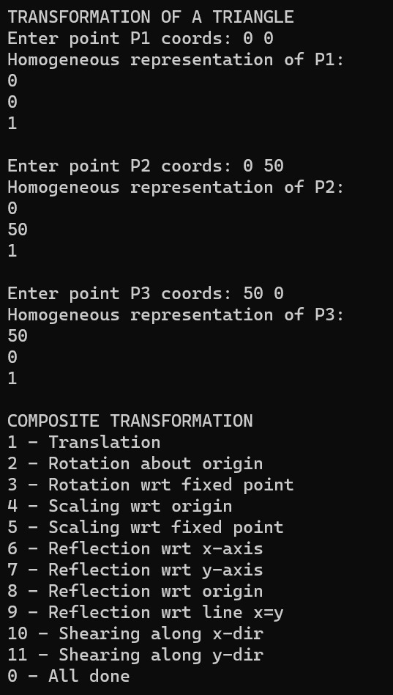 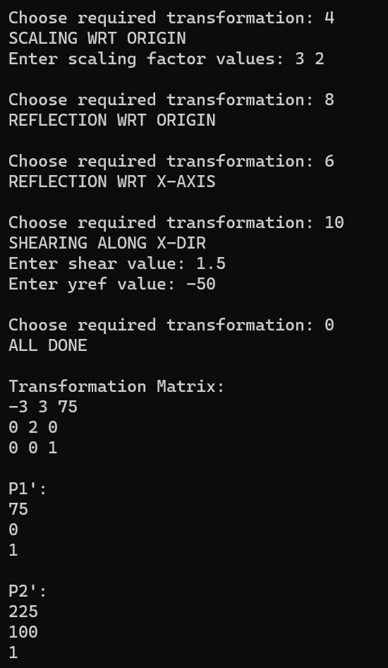 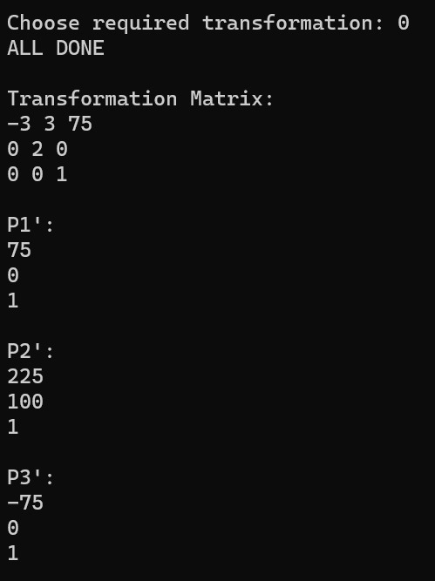

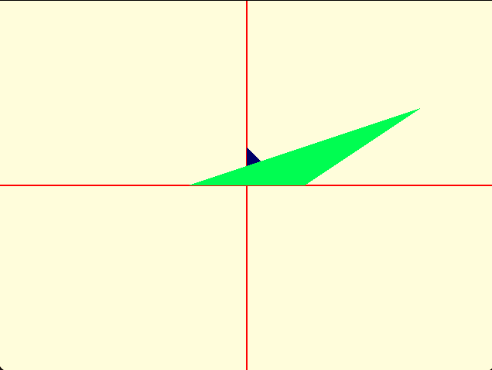

b) Create a window with any 2D object and a different sized viewport. Apply window to viewport transformation on the object. Display both window and viewport.

**Source code:**

#define **GL_SILENCE_DEPRECATION**

#include<GLUT/glut.h>

#include<stdio.h>

#include<iostream>

#include<math.h>

using namespace std;

float xvmax = 640, yvmax = 480, xwmax = 1280, ywmax = 960;

void **myInit_window**() {

**glClearColor**(1, 1, 1, 1.0);

**glColor3f**(0.0f, 0.0f, 0.0f);

**glPointSize**(3);

**glLineWidth**(3);

**glMatrixMode**(GL_PROJECTION);

**glLoadIdentity**();

**gluOrtho2D**(0.0, 1280.0, 0.0, 960.0);

}

void **myInit_viewport**() {

**glClearColor**(1, 1, 1, 1.0);

**glColor3f**(0.0f, 0.0f, 0.0f);

**glPointSize**(3);

**glLineWidth**(3);

**glMatrixMode**(GL_PROJECTION);

**glLoadIdentity**();

**gluOrtho2D**(0.0, 640.0, 0.0, 480.0);

}

void **displayaxes_window**() {

**glBegin**(GL_LINES);

**glColor4f**(0, 0.5, 0, 1);

    //y - axis

**glVertex2d**(640, 0);

**glVertex2d**(640, 960);

    //x - axis

**glVertex2d**(0, 480);

**glVertex2d**(1280, 480);

**glEnd**();

}

void **displayaxes_viewport**() {

**glBegin**(GL_LINES);

**glColor4f**(0, 0.5, 0, 1);

    //y - axis

**glVertex2d**(320, 0);

**glVertex2d**(320, 480);

    //x - axis

**glVertex2d**(0, 240);

**glVertex2d**(640, 240);

**glEnd**();

}

void **drawObject**(int window) {

    float x1, y1;

    cout **<<** "Enter point 1 coordinates: ";

    cin **>>** x1 **>>** y1;

    float x2, y2;

    cout **<<** "Enter point 2 coordinates: ";

    cin **>>** x2 **>>** y2;

    float x3, y3;

    cout **<<** "Enter point 3 coordinates: ";

    cin **>>** x3 **>>** y3;

    if (window) {

        cout **<<** "window\n";

**glBegin**(GL_TRIANGLES);

**glColor4f**(0.4, 0, 0.8, 1);

**glVertex2d**(x1 + (xwmax / 2), y1 + (ywmax / 2));

**glVertex2d**(x2 + (xwmax / 2), y2 + (ywmax / 2));

**glVertex2d**(x3 + (xwmax / 2), y3 + (ywmax / 2));

**glEnd**();

**glFlush**();

    }

    else {

        cout **<<** "viewport\n";

        float sx = xvmax / xwmax, sy = yvmax / ywmax;

        float S[3][3] = { {sx, 0, 0}, {0, sy, 0}, {0, 0, 1} };

        float T[3][3] = { {x1, y1, 1}, {x2, y2, 1}, {x3, y3, 1} };

        float R[3][3] = { {0, 0, 0}, {0, 0, 0}, {0, 0, 0} };

        for (int i = 0; i < 3; i++) {

            for (int j = 0; j < 3; j++) {

                for (int k = 0; k < 3; k++) {

                    R[i][j] += S[i][k] * T[k][j];

                }

            }

        }

**glBegin**(GL_TRIANGLES);

**glColor4f**(0, 0, 0.8, 1);

**glVertex2d**(R[0][0] + (xvmax / 2), R[0][1] + (yvmax / 2));

**glVertex2d**(R[1][0] + (xvmax / 2), R[1][1] + (yvmax / 2));

**glVertex2d**(R[2][0] + (xvmax / 2), R[2][1] + (yvmax / 2));

**glEnd**();

**glFlush**();

    }

}

void **plotWindow_window**() {

**myInit_window**();

**glClear**(GL_COLOR_BUFFER_BIT);

**displayaxes_window**();

**drawObject**(1);

**glFlush**();

**glutSwapBuffers**();

}

void **plotWindow_viewport**() {

**myInit_viewport**();

**glClear**(GL_COLOR_BUFFER_BIT);

**displayaxes_viewport**();

**drawObject**(0);

**glFlush**();

**glutSwapBuffers**();

}

int **main**(int argc, char* argv[]) {

**glutInit**(&argc, argv);

**glutInitDisplayMode**(GLUT_DOUBLE | GLUT_RGBA);

**glutInitWindowSize**(xwmax, ywmax);

    int window = **glutCreateWindow**("Window");

**glutInitWindowSize**(xvmax, yvmax);

    int viewport = **glutCreateWindow**("Viewport");

**glutSetWindow**(window);

**glutDisplayFunc**(**plotWindow_window**);

**glutSetWindow**(viewport);

**glutDisplayFunc**(**plotWindow_viewport**);

**glutMainLoop**();

    return 1;

}

**Output**

**Input**

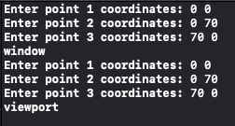

**Window**

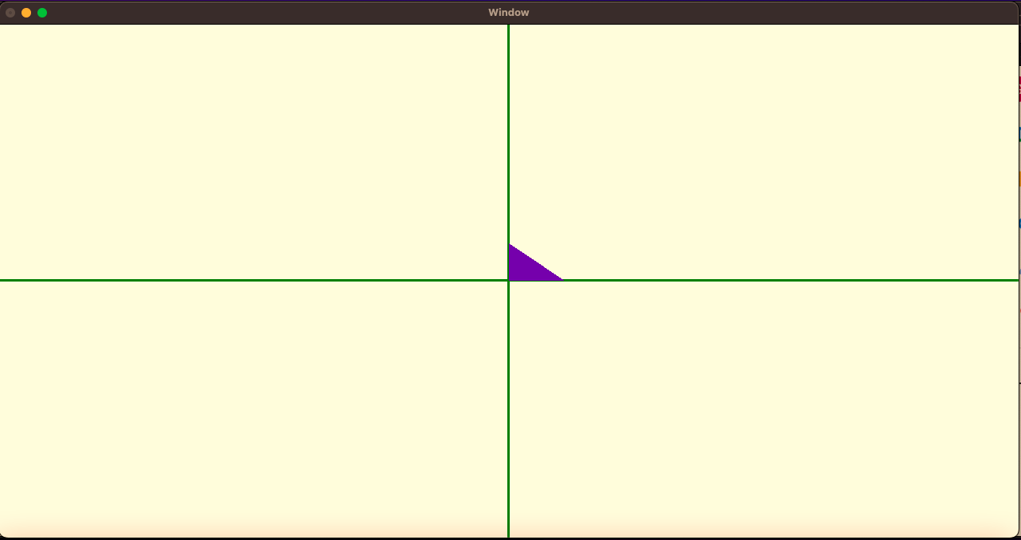

**Viewport**

